# Session-2

<https://www.youtube.com/watch?v=h5bnq6j3ZuA>

### Interface types are 3 types: only interface parameter will change when changing the Interface type .

1. ABAP DDIC-Based Interface.
2. XML Schema Based Interface 🡨 For webdynpro designing through WD form builder
3. Smart form Compatible Interface.

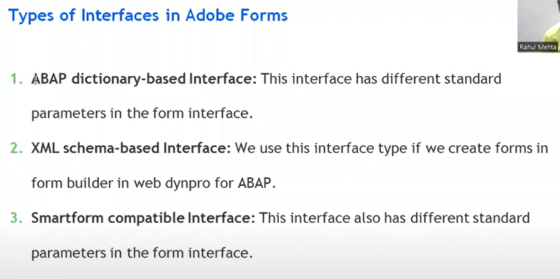

### Layout types :

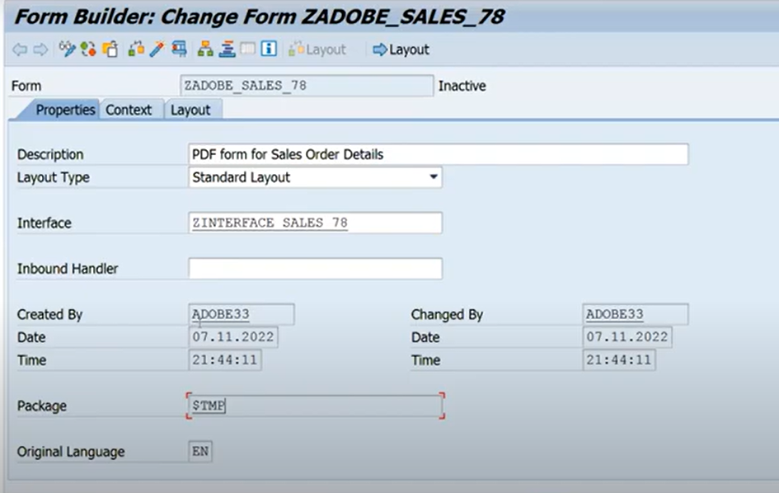

Whenever you are going for adobe layout – we have 4 types of layouts

1. Unknown Layout Type
2. xACF Layout 🡺 for integrate WD and activex must be enabled
3. ZCI Layout 🡺when integrate form into webdypro at runtime
4. Standard Layout 🡺 adobe forms/ E-Mail/interactive forms/Archieve also and not for WD application

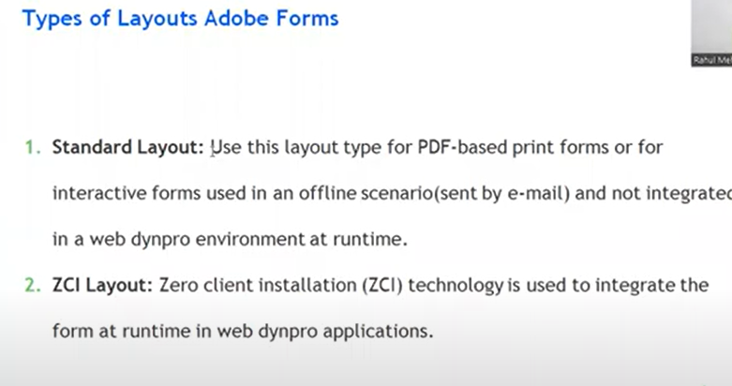

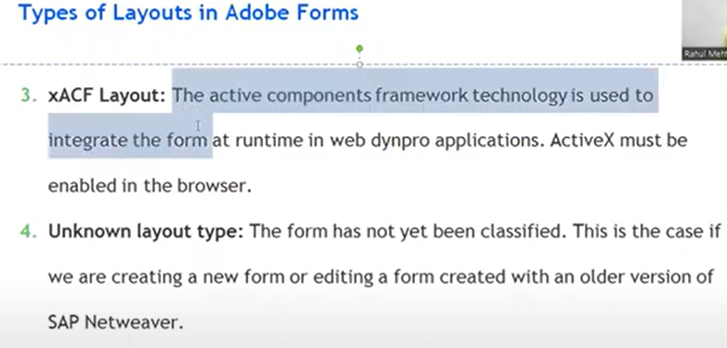

Most preferable layout is standard layouts.

Views:

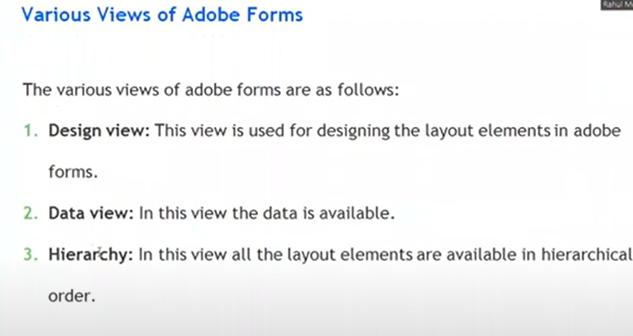

1. Hierarchy :

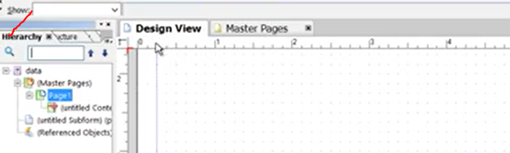

### Master and Body Pages:

1. Master pages when you click on to layout of master page automatically present the master pages.

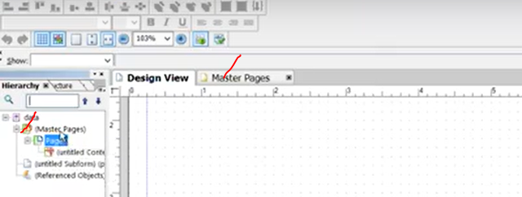

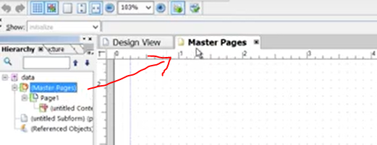

Note in adobe forms at least one master page is default.

* + This master page creates through the ADS automatically.

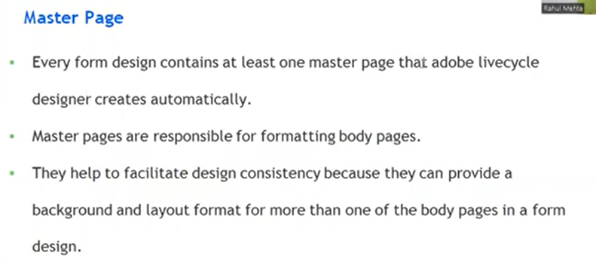

* + ADS creates the automatically at least one Master page
  + Why the concept of master page: responsible for formatting of the body pages.
  + Purpose of master page to provide the design consistency. suppose I am saying I have thousand body pages which are coming in the output and all those 1000 body pages, we want a common thing , so but you will do and go for that thing Master page and it will automatically appear on all the 1000 body pages .
  + Master Page is the common page, it is automatically applicable to the all the body pages.
  + Master page used for responsibility to formatting the body pages, suppose I want the logo on all the body pages and the best way always design the logo on the master page , which sets in automatically appear on all the body pages.

#### Body Pages

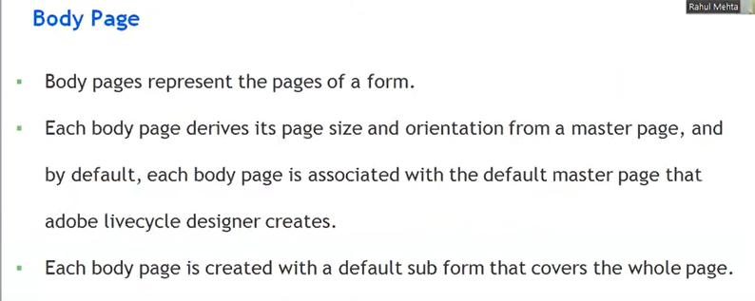

* Body pages are actual page of the form.
* Output you are seeing the adobe form or pdf form, all those are body pages.
* Master page whatever you will do, those will appear on body page. But your output of the pdf form all your body pages only.
* 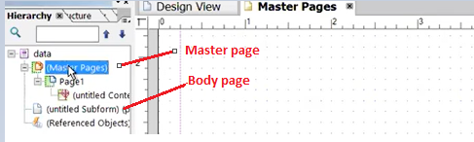
* Design View 🡪 body page,
* Body page size will come automatically get form the master page.( whenever decrease the size of the master page it is automatically reflecting the body page also ).

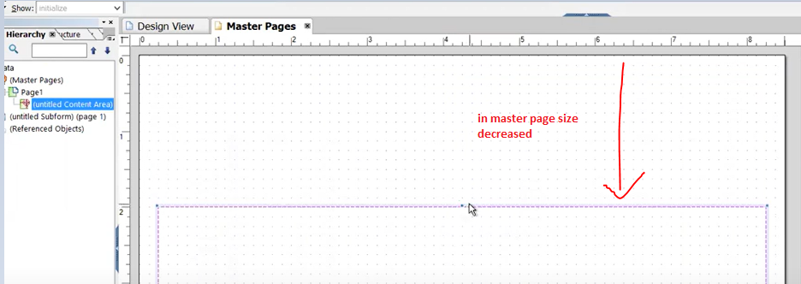

And this size also automatically decreased to the body pages also.

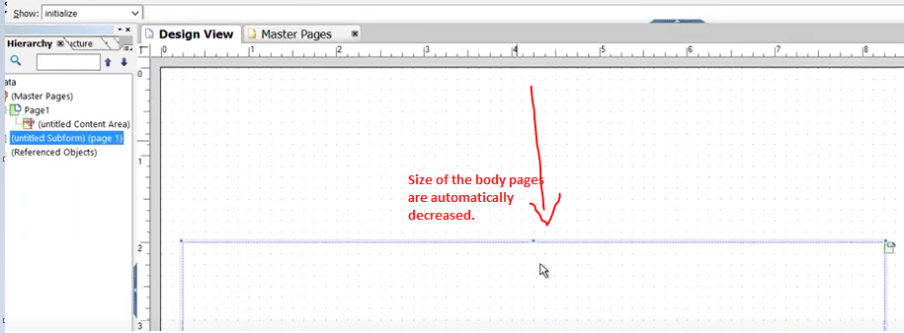

Body page size and orientation comes from master page only.

Body page is actual output of the pdf form.s

s

Whatever ele

### ABAP DDIC based Interface:

1. Import:
2. 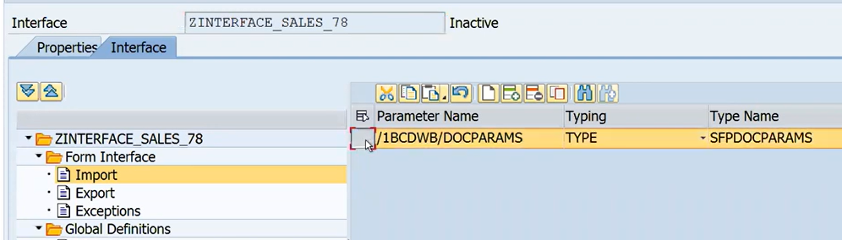
3. Export:
4. 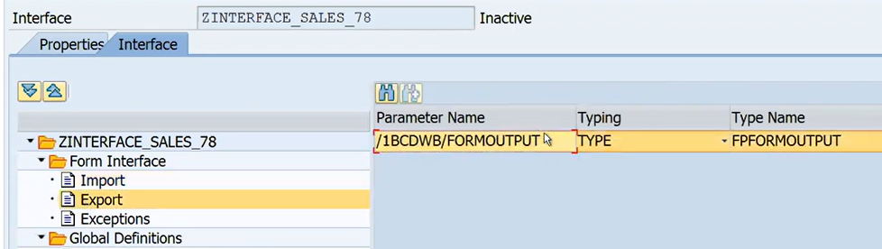
5. Exceptions:
6. 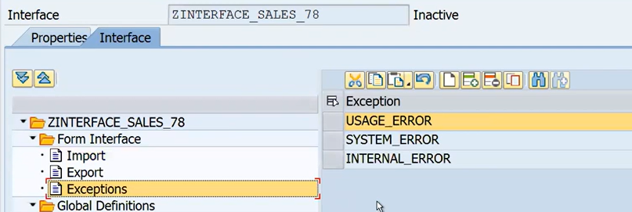
7. If you chosen the ABAP DDIC based Interface type, few standard parameters(Default) will get automatically.

### XML-Schema Based Interface

1. 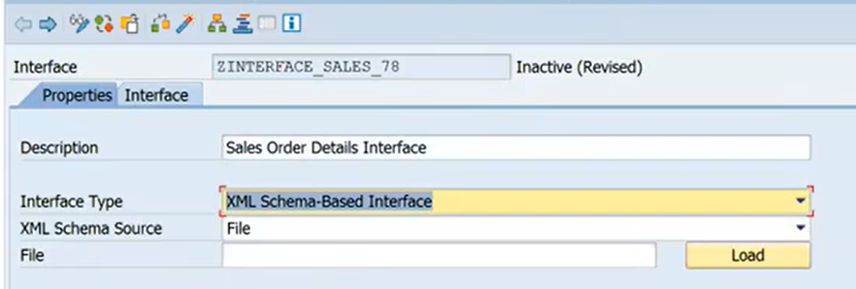
2. 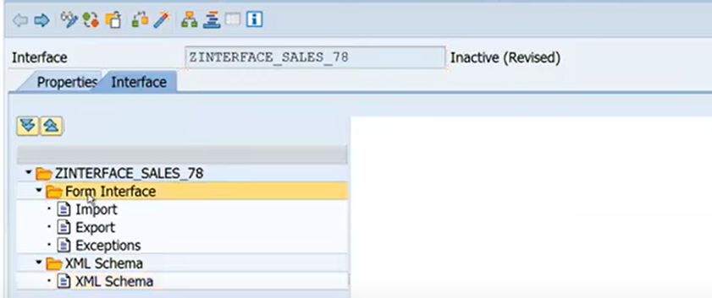
3. 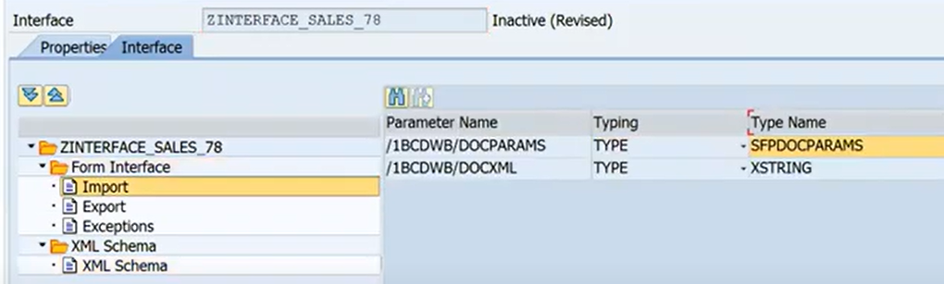

### Smart form-based Interface:

1. This is same like as smartform -Interface.
2. 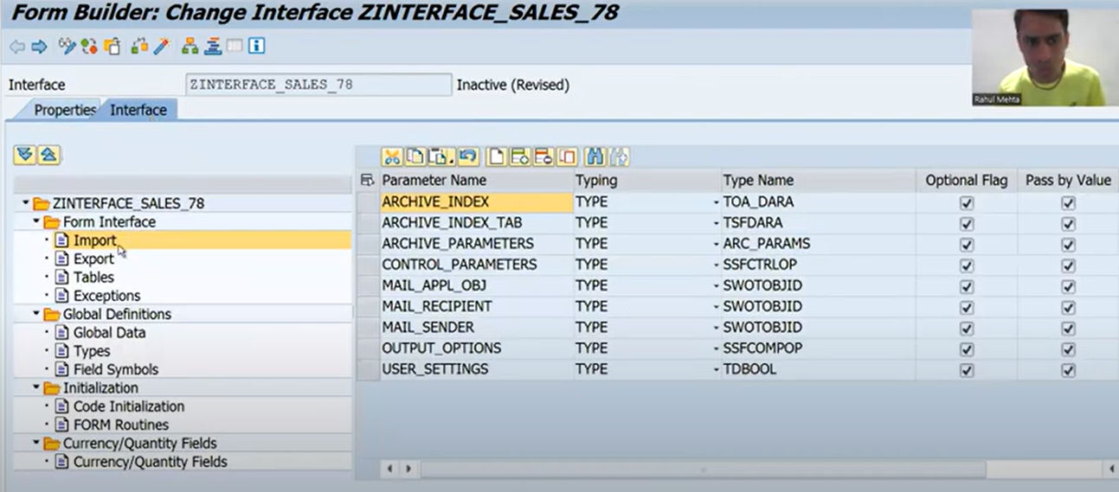
3. In smartform

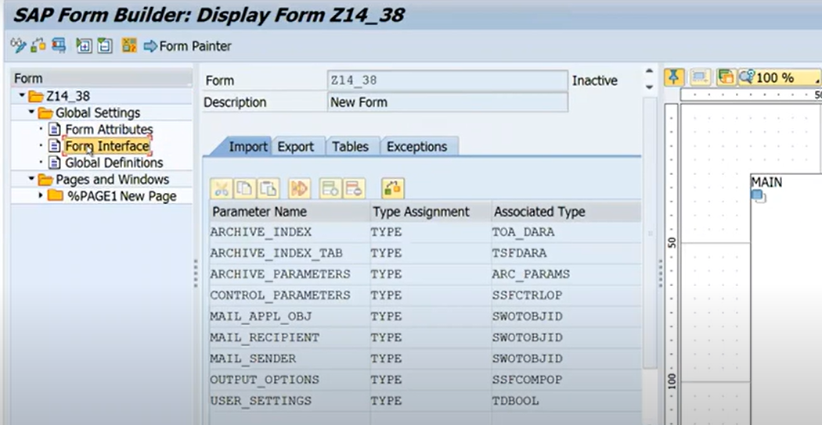

# Form Designing:

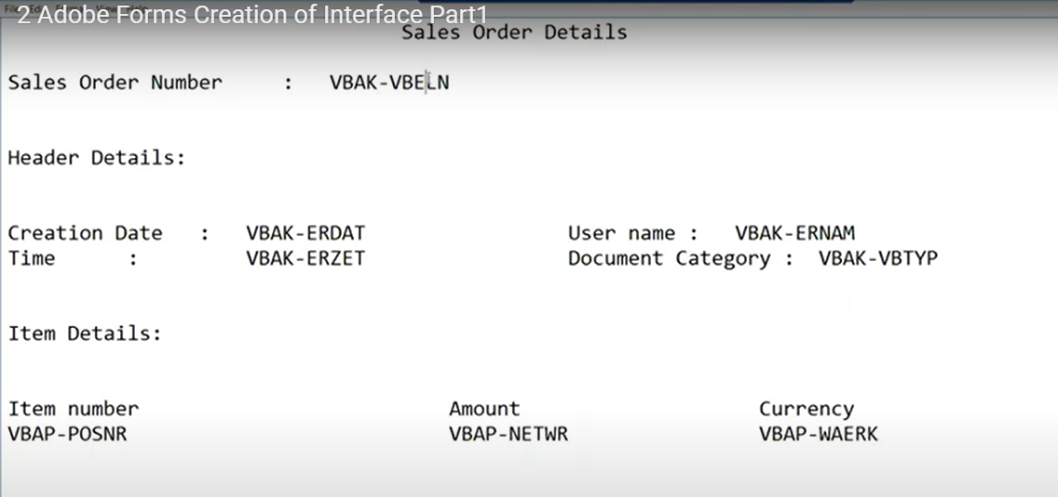

Tables:

VBAK/VBAP

## Create the interface

1. Create the internal table and work area.. etc variables and logic also implemented.
2. Use this interface inside the form layout.

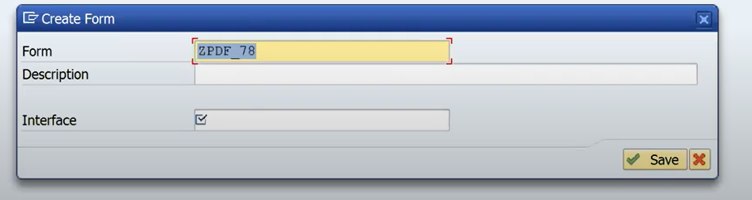

1. Go to tcode :SFP 🡨 to create the adobe forms
2. Firstly, need to create the Interface.

### Designing the interface:

1. Choose the radio button interface and give the interface name, here

Interface name as : ZINTERFACE_SALES_78

Click on create button.

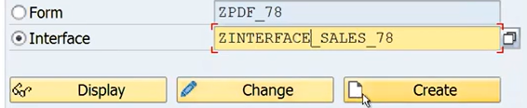

1. Neat screen give the description:

Whenever you are creating the interface, we have to choose the interface type

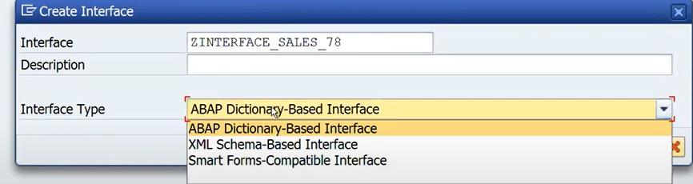

1. Choose the abap Dictionary based Interface and give the DDIC

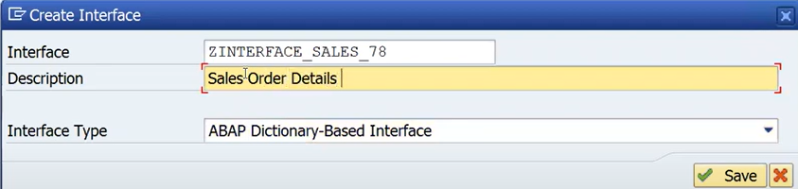

Whenever I will go for the save.

1. Next screen: you will get the 2 default values under the and exceptions also

Form Interface of import/ Export/Exception Default values.

Import:



Export:



Exceptions:



If you chosen the ABAP DDIC based Interface type, few standard parameters(Default) will get automatically.

Note: Most preferable interface is ABAP-DDIC based Interface

Whenever you want to give the input, we are using import node.

### Adding import parameters☹Input)

* Go to Import in the Interface and click on append row button.

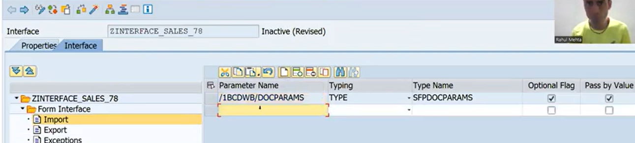

Now provide the parameter under the import .

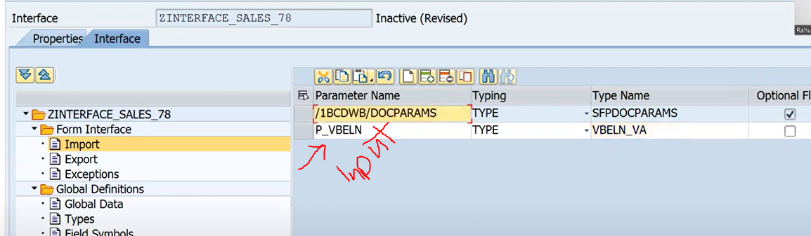

We have the five columns from VBAK and 3- columns from VBAP., so we can declare the Internal table-VBAP and works area as -VBAK.

* Go to Se11 Create the Header structures.
* Name: ZSTRVBAK_78 create it

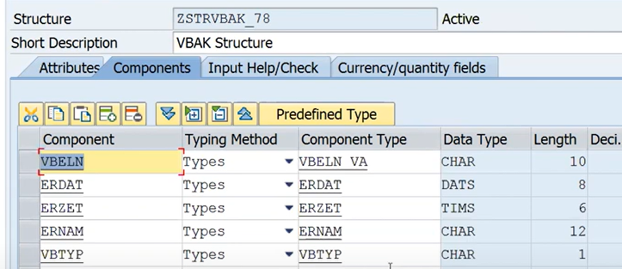

* Create the table type as ZTSRTRVBAK_78 of VBAK

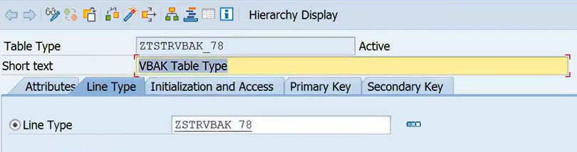

Activate

Header Work are and table type is ready

* Now create the header and table type variables at the global declarations.

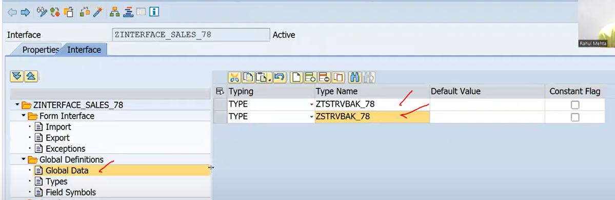

# Session-3: <https://www.youtube.com/watch?v=q9wUXKKTSFg&list=PLM3lhmHjSeIRGW2wM3DxT82_1kTC7pdSu&index=3>

* And same we have to create the work area and table type of sales order item details table.

On VBAK.

Global vbap structure defined

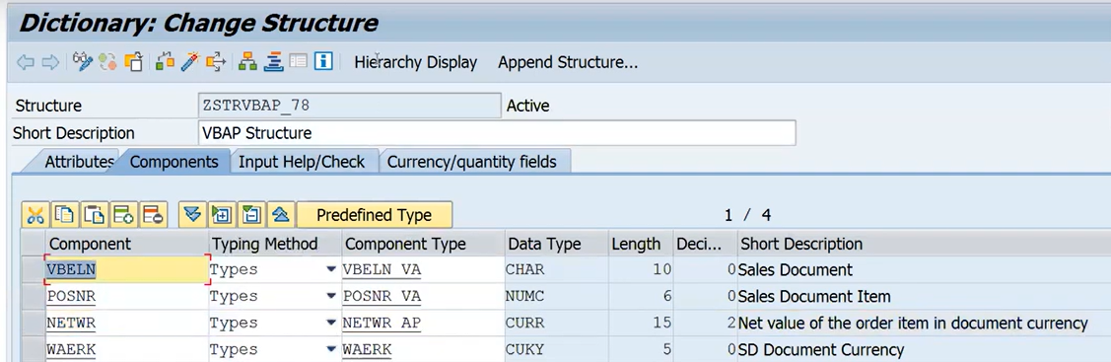

Create the table type for VBAP

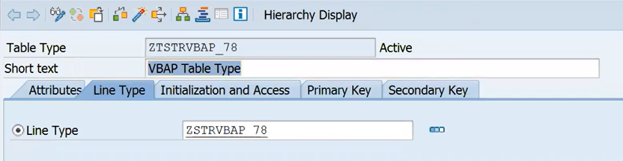

Now declare the work area and table type in Global Node in Interface.

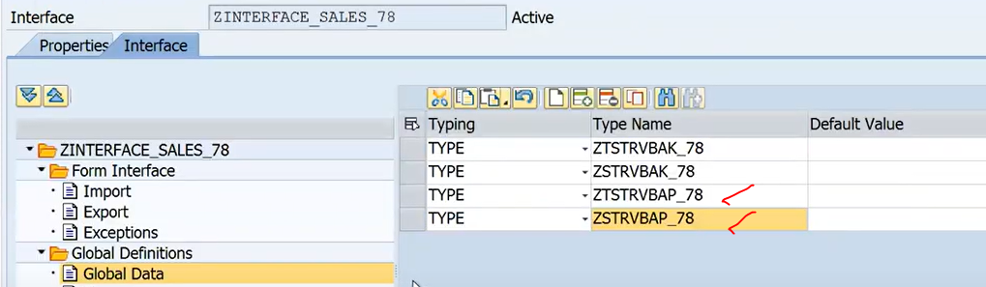

Here we have taken

1. the one input parameter P_VBELN in the import tab of form interface
2. Declare the work areas and table type for vbak and vbap table types.

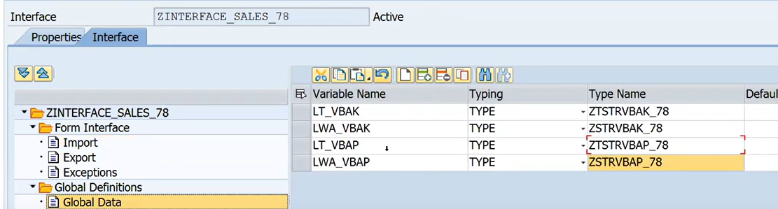

Declaration part has been completed. Now implement the logic.

Logic we will implement in the interface~code Initialization.

## Build the logic:

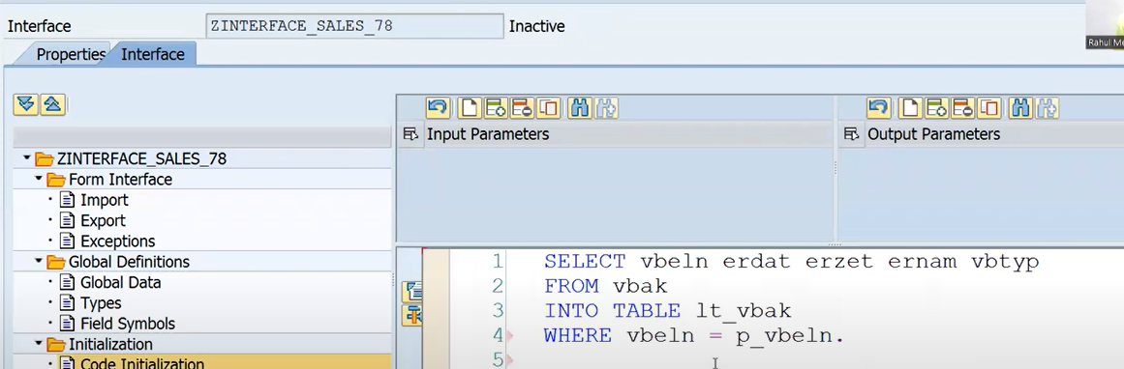

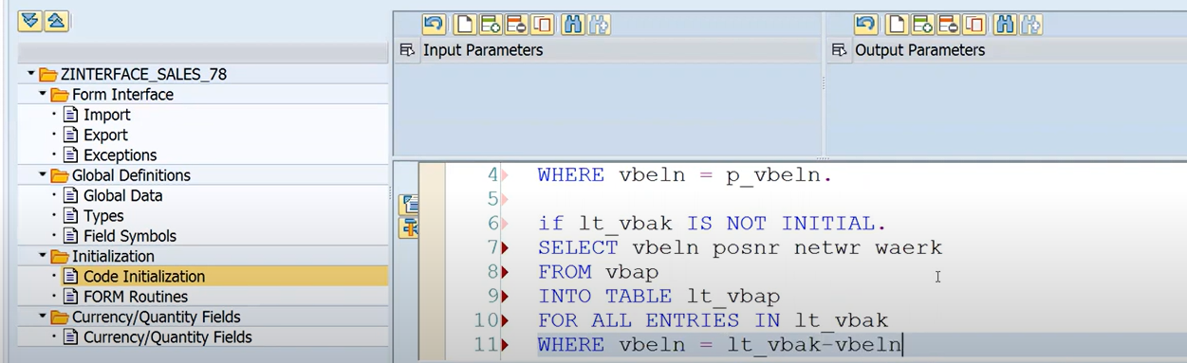

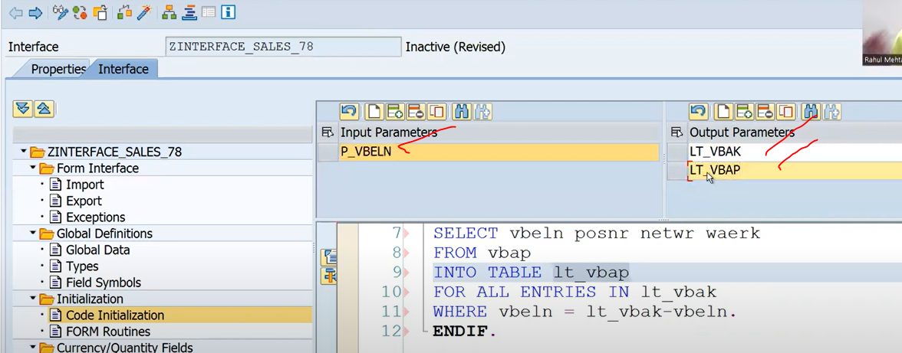

Now activate the interface

Now our interface ready

Input : P_VBELN

OUTPUT: LT_VBAK/LT_VBAP.

Logic and declaration everything done in the interface only.

# Session-4-Layout Designing

<https://www.youtube.com/watch?v=wwKpgqPM-XA&list=PLM3lhmHjSeIRGW2wM3DxT82_1kTC7pdSu&index=4>

Tcode : SFP

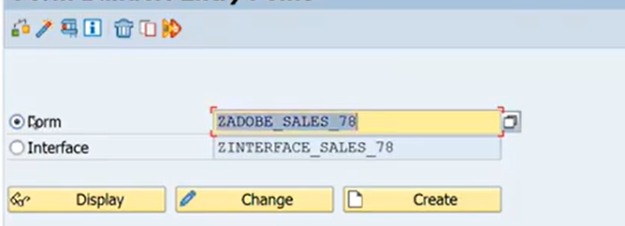

Click on create button

Next screen provide the description and Interface.

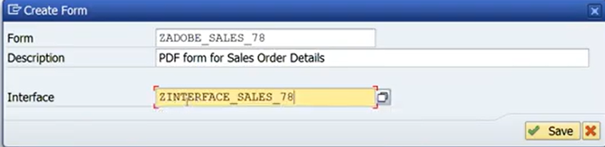

Click on SAVE button,

Next screen seems to like this:

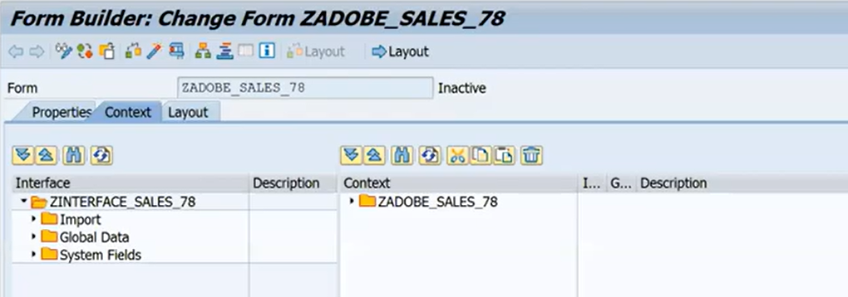

Form Builder has 3 tabs

1. Properties
2. Context
3. Layout

Properties tab: give the generic information of your form.

* Description
* Interface Name



Whenever you are going for adobe layout – we have 4 types of layouts

Unknown Layout Type

xACF Layout 🡺 for integrate WD and activex must be enabled

ZCI Layout 🡺when integrate form into webdypro at runtime

Standard Layout 🡺 adobe forms/ E-Mail/interactive forms/Archieve also and not for WD application

Note: Most preferrable layouts is standard layout.

## Mapping Fields(Interface to Adobe section)

### Context tab:

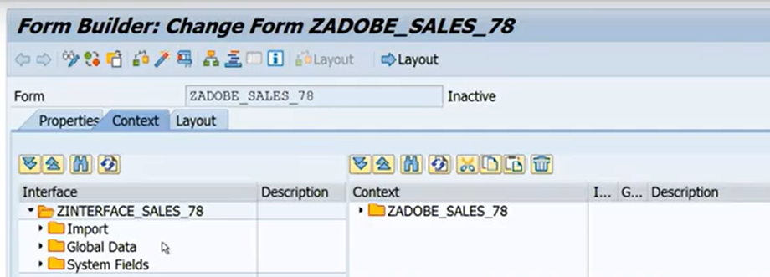

In context tab : we have two sections.

1. Interface name 🡪 ZINTERFACE_SALES_78
2. Context🡪 adobe form section(ZADOBE_SALES_78)

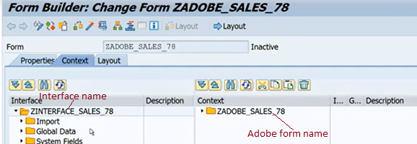

In interface section, whatever we have defined those variables available to here such as import/Global/System fields.

Whenever you create the Adobe based DDIC Interface and whatever the seen the interface all parameters comes into the Adobe form layout and in addition to that added the system fields.

System Fields: - 4 SFPSY-DATE/TIME/USERNAME/SUBRC

Context tab: where the actual data resides, whatever you required the data you can simple drag and drop interface section to context section. Those things mapped to Interface to Adobe sections

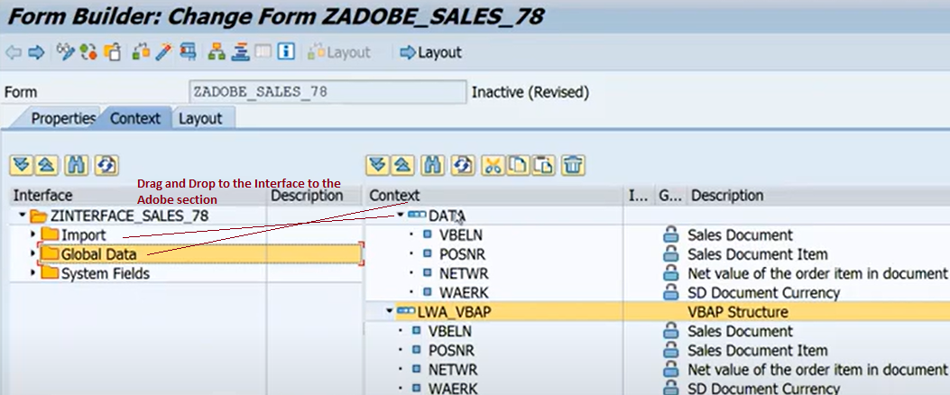

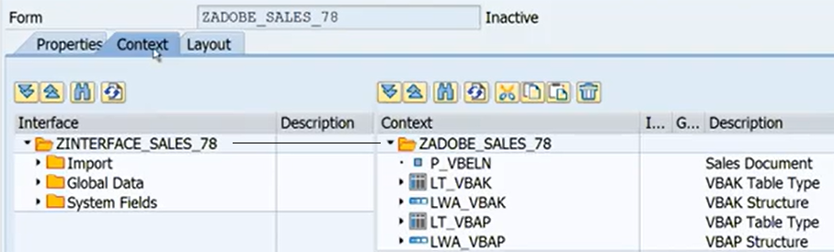

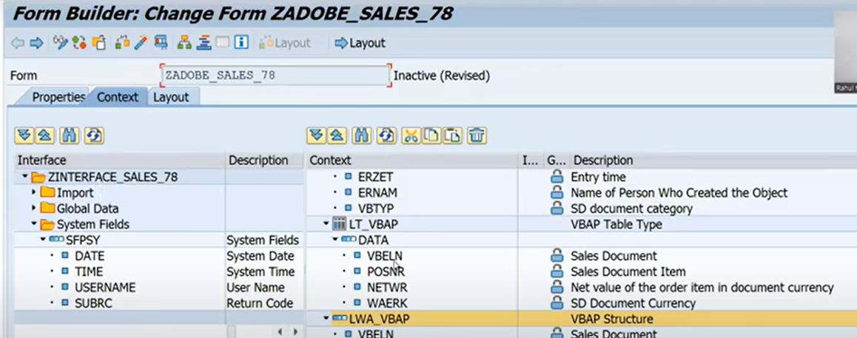

Table is mapping under the Data tab

#### Session-5

### <https://www.youtube.com/watch?v=DeM5XGmYbZk&list=PLM3lhmHjSeIRGW2wM3DxT82_1kTC7pdSu&index=5>

##### Layout tab:

* When design the layout you have to click the layout tab
* Once click the Layout tab, new design window will open.

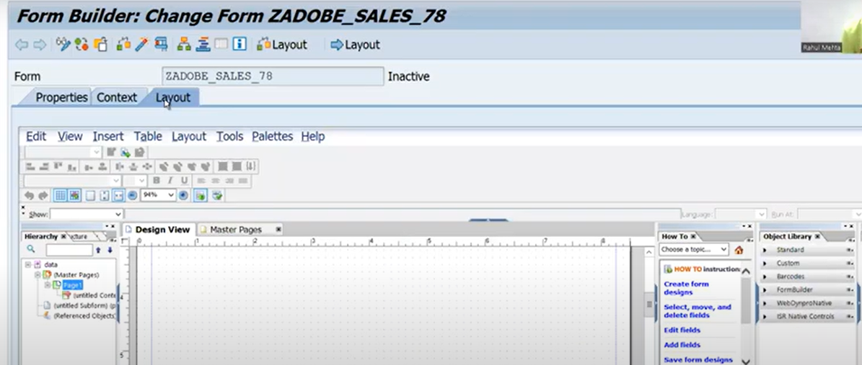

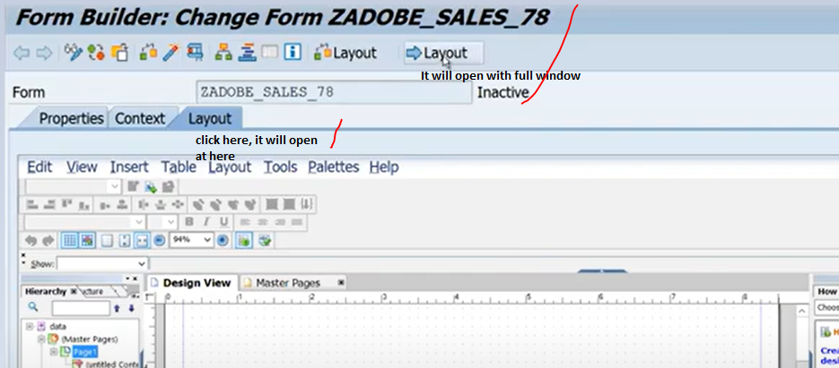

Full window will capture

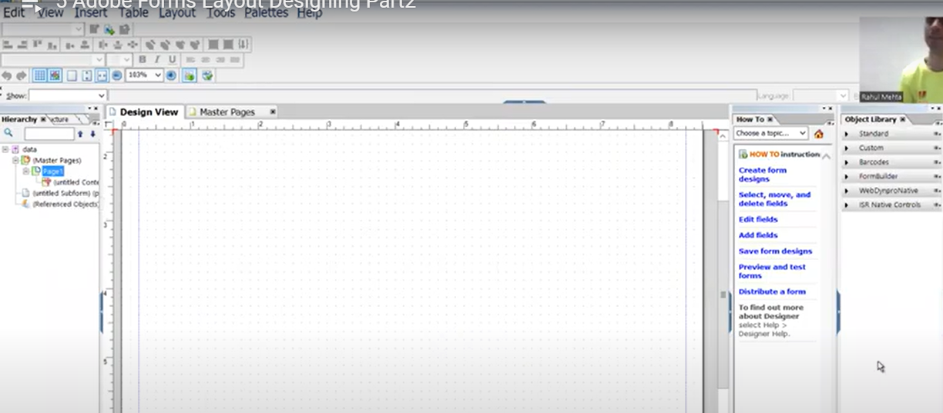

Important points:



1. Hierarchy :



Whatever element is designed, you will se here all the nodes elements able to see here in hierarchy order.

1. Data View:

Data of your pdf forms will be available in the data view.

1. Design View

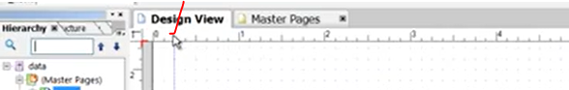

You will the design the layout using the design view.

1. Master pages when you click on to layout of master page automatically present the master pages.





Note in adobe forms at least one master page is default.

* + This master page creates through the ADS automatically.



* + ADS creates the automatically at least one Master page
  + Why the concept of master page: responsible for formatting of the body pages.
  + Purpose of master page to provide the design consistency. suppose I am saying I have thousand body pages which are coming in the output and all those 1000 body pages, we want a common thing , so but you will do and go for that thing Master page and it will automatically appear on all the 1000 body pages .
  + Master Page is the common page, it is automatically applicable to the all the body pages.
  + Master page used for responsibility to formatting the body pages, suppose I want the logo on all the body pages and the best way always design the logo on the master page , which sets in automatically appear on all the body pages.

#### Body Pages



* Body pages are actual page of the form.
* Output you are seeing the adobe form or pdf form, all those are body pages.
* Master page whatever you will do, those will appear on body page. But your output of the pdf form all your body pages only.
* 
* Design View 🡪 body page,
* Body page size will come automatically get form the master page.( whenever decrease the size of the master page it is automatically reflecting the body page also ).



And this size also automatically decreased to the body pages also.



Body page size and orientation comes from master page only.

Body page is actual output of the pdf form.s

## Session -6

<https://www.youtube.com/watch?v=f7MnHhPTgUE&list=PLM3lhmHjSeIRGW2wM3DxT82_1kTC7pdSu&index=6>

Now Designing the layout:

Example Designing the layout:

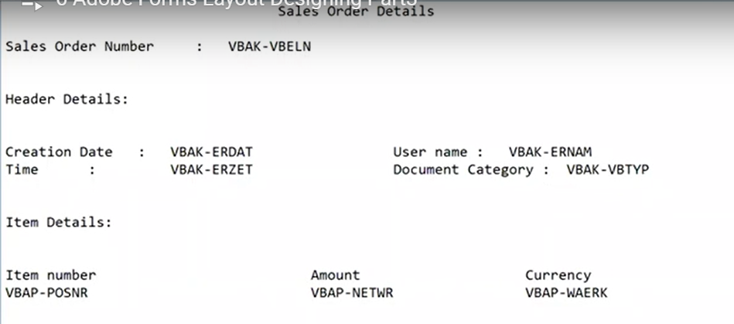

In smart form for every section we created the Windows but in adobe forms for every section we need to create the sub forms.

Smartforms ------🡪 Windows

Adobe forms -----🡪 sub forms.

In adobe form for every section, we have to create the subforms.

Design the body pages first.

Body page means 🡪 Sub forms..

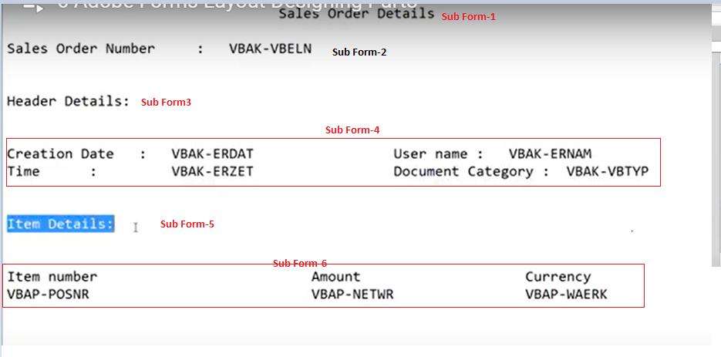

Design the each sub form:

Sales Order Page: Main Body page to the Master page. -

* How to rename the body page:

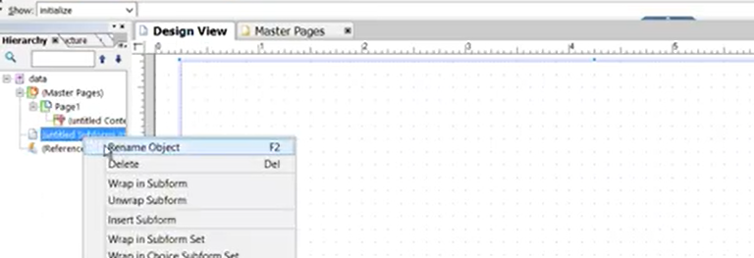

or

Or double click on sub form, it will open in change mode and write your name also.

Given Sales Order Page: this is our body page, where we will do the full layout page.

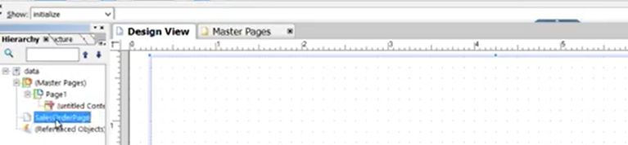

Created the main body page:

* Insertion of the sub form:

1. Right click on Sales Order Page, select the Insert SubForms
2. Before inserting the sub form 🡪 need to identify it do we have the dynamic data or not, here item details are dynamic only, if the line item will increase our data should pass on to the next page.
3. If your layout has dynamic data, you should take your page as “**FLOAT**” not as the “**position**”

Float 🡪 Dynamic

Position 🡪 Static

If you don’t have the dynamic data, you can take page as **“POSITION”**, not the “FLOAT”

**How to do this ?**

* + **Note: every layout element has a Object, means you can set the properties using the object.**
  + Click the select the Body page( sales order Page )
  + If I select the “SalesOrderPage” 🡪 most important point if you think during designing of the pdf forms , you lost some Propertirs/ not able to see the layout elements/ you forgot something.--> in this case you can reset the “**Pallet locations”**

**Then you can able to see each and everything again..**

Ex: now I am selecting the “SalesOrderPage” but unable to see the object of the particular page.

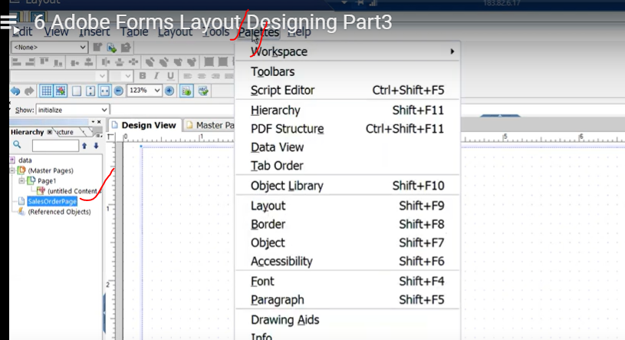

So here select the page 🡪 go to pallete (menu ) 🡪 workspace 🡪Reset Pallete Locations.s 🡪

Now your object is resets.

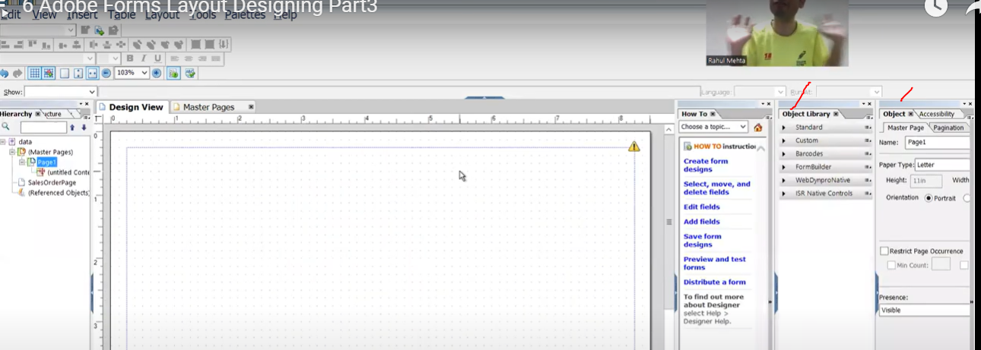

Just Pallete object 🡪 put it on the tops, that is used for whenever they want to do/set the object of the any layout elements, they are always able to see here.s

🡪If I click on the Master page 🡪this is the object of your masterpage.

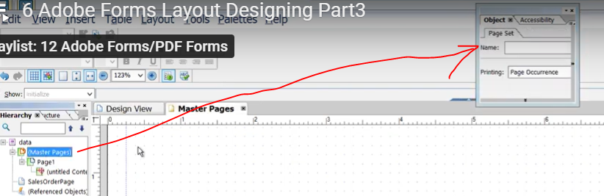

🡪if I click on to the body page 🡪 able to see the object of the body page.

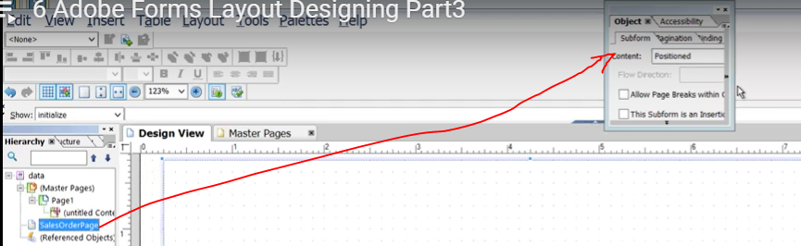

Now change the page as **Float ) Float used for float the data dynamically**

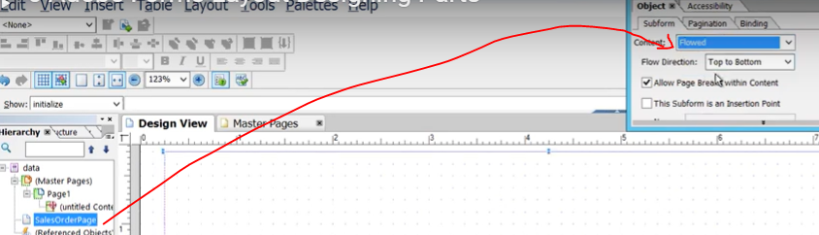

## SubForms:



* Creating the SubForm:
* Right click on “SalesOrderPage” 🡪Insert SubForm (For title)

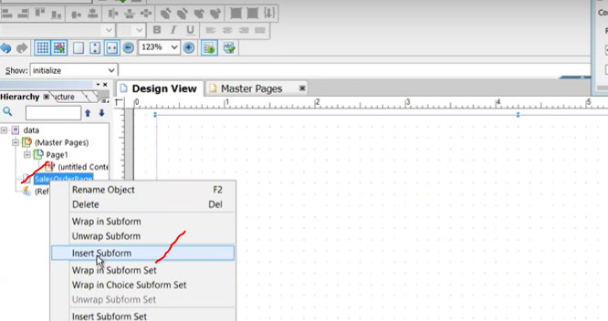

Get screen like this, here you can increase the size and length.

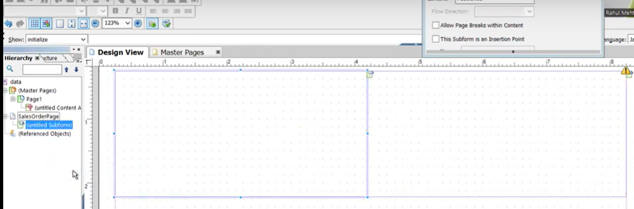

Now make this sub form as shaort, bcz inside we are display the title:”Sales Order Details “.



Sub form Content: Positional

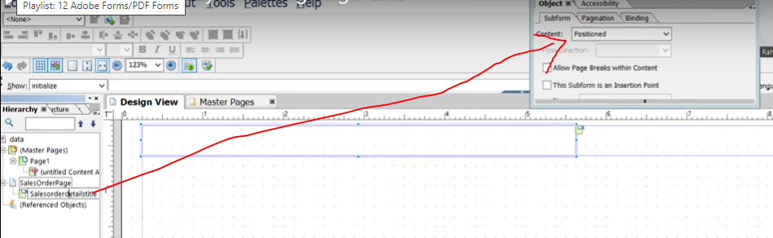

Now I want to print the text as “sales order details” .

* Simply select the subform 🡪 Insert(menu) and select the 0-Standard 🡪select the “Text”

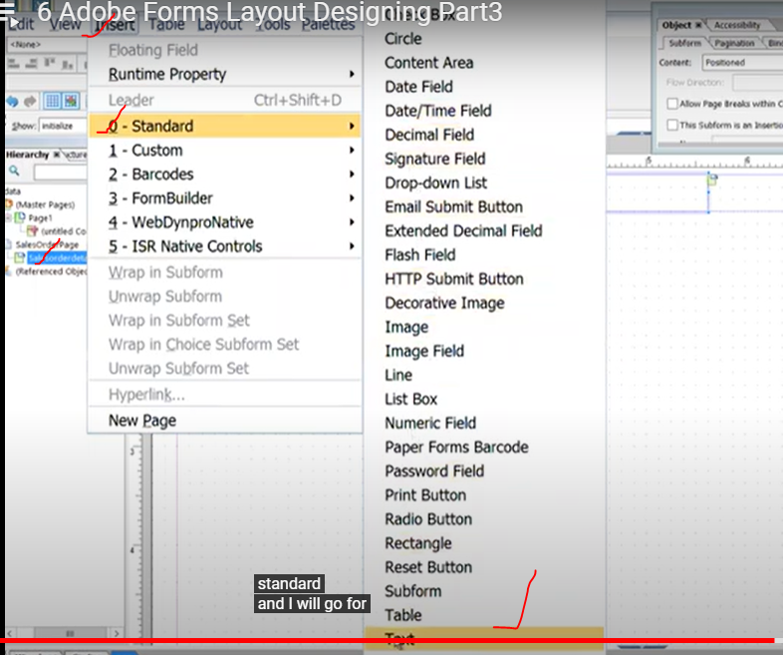s

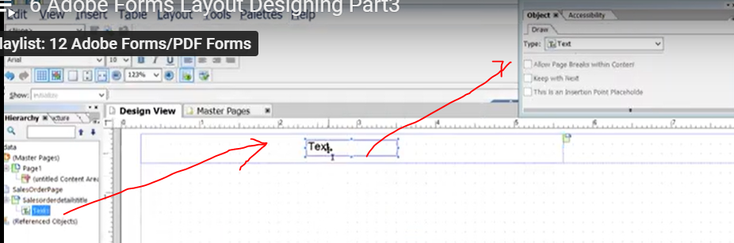

Change the value here only: Sales Order Details

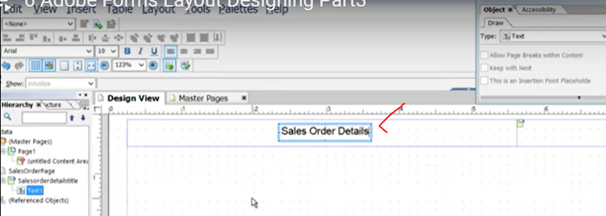

Now rename it:

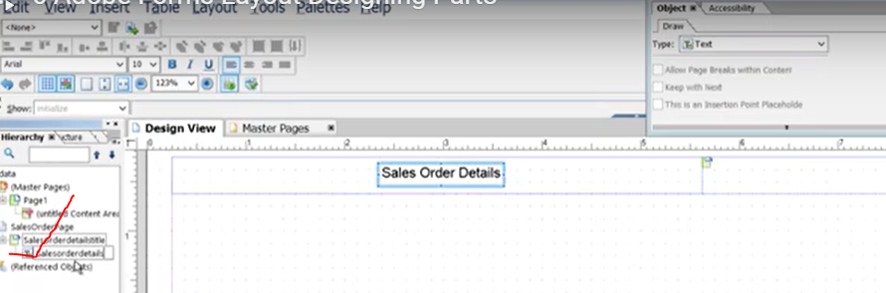

## Sub Form-2 for Sales Order Number

* 
* Now right click on the “SalesOrderPage” 🡪 body page
* Click on insert SubForm

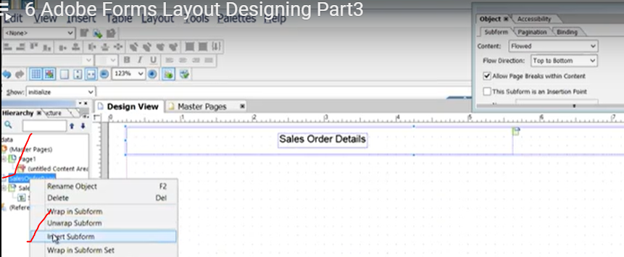

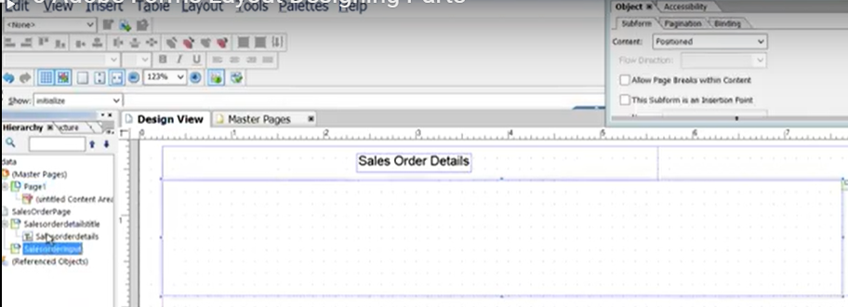

Rename the form as “SalesOrderValue”

Now take the Text Field:

Text Field: Label + Value

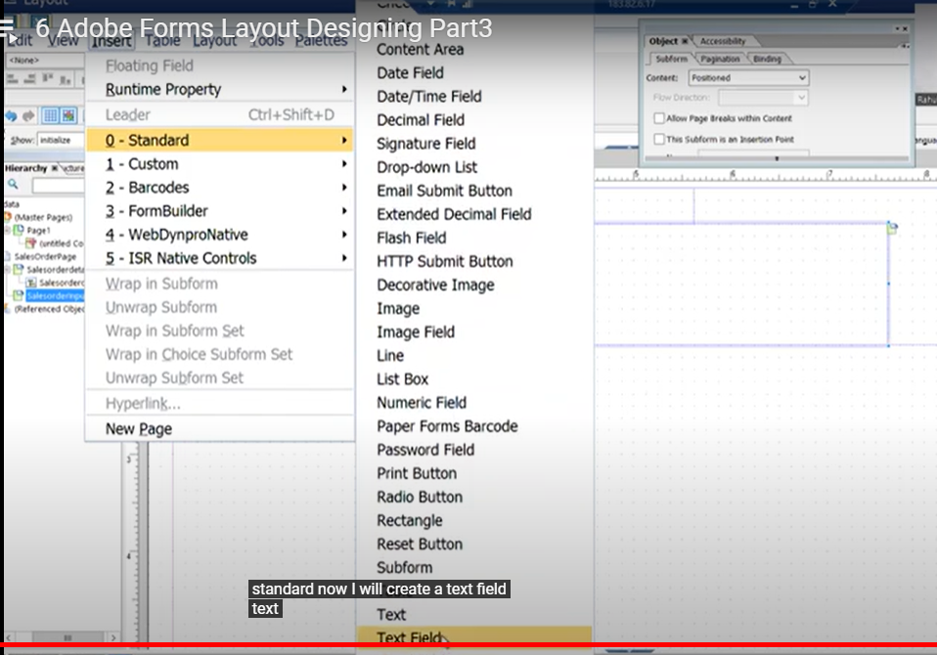

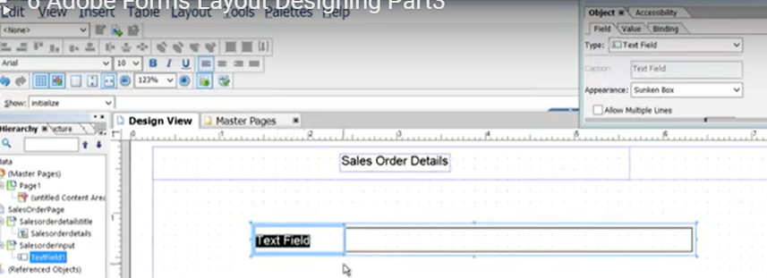

Change the label name as “sales Order Number”

We know every element is the object.s and now print the value of the sales order number

Simply select the TextField -element 🡪it will open the object🡪 now open the binding tab

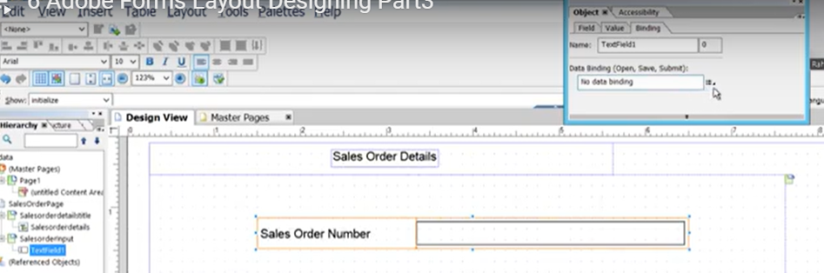

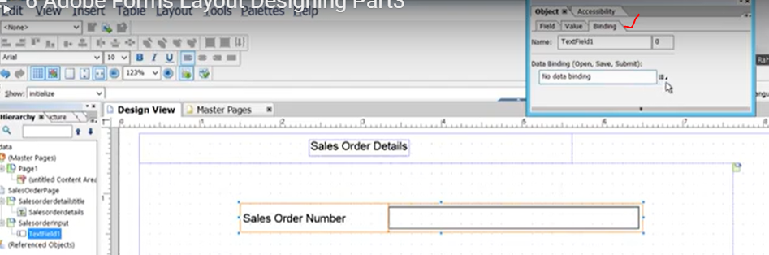

Her we have the data binding , select that , go to the “Adobe form Context: ZADOBE_SALES_78” 🡪 able to see the all the mapped variables from interface: select the “P_VBELN”

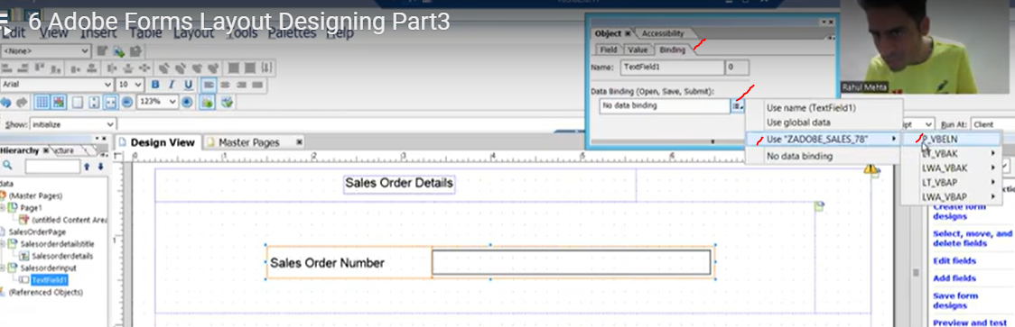

P_VBELN 🡪 is the input of the sales order number.

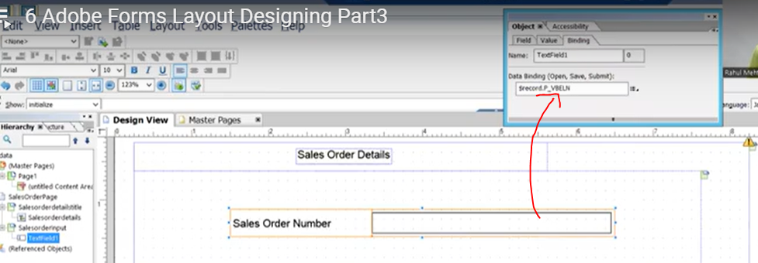

Binding : $record.p_vbeln

We binded the P_VBELN

Click on SAVE 🡪 

## Sub Form-3

* Create the sub form-3 under the body page
* Rename the sub form: HeaderDetailsTitles
* Insert the element as Text

Select subform -> insert (menu) 🡪standard 🡪Text

Now change the text as : Header Detailss

Save it

s

# Session-7:

## https://www.youtube.com/watch?v=2Il6JZIWAkA&list=PLM3lhmHjSeIRGW2wM3DxT82_1kTC7pdSu&index=7

### create the sub form:

`` right click on the body page 🡪click on Insert sub form.

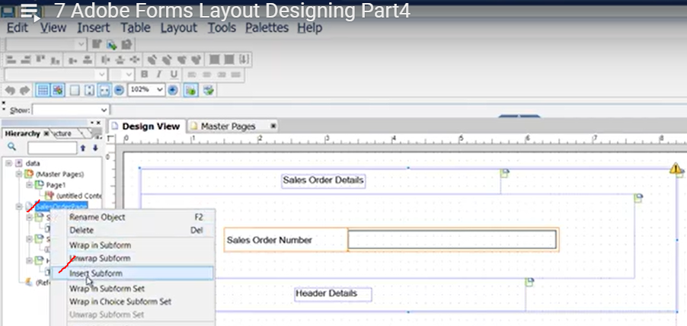

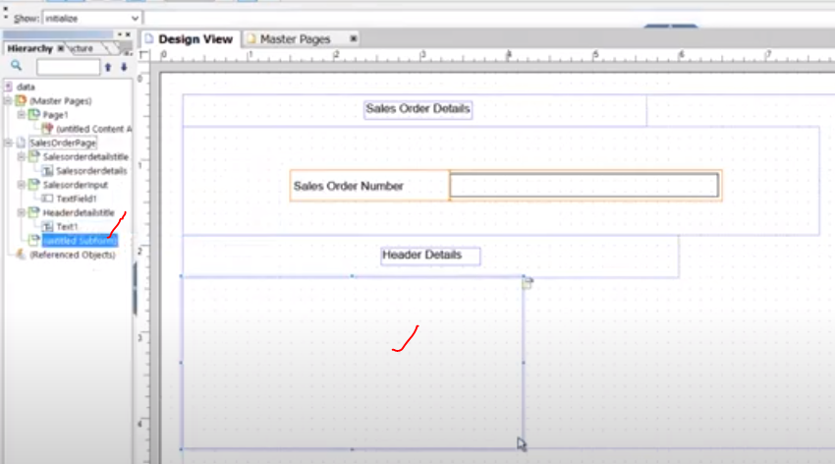

-- Now increase the width of the subform.

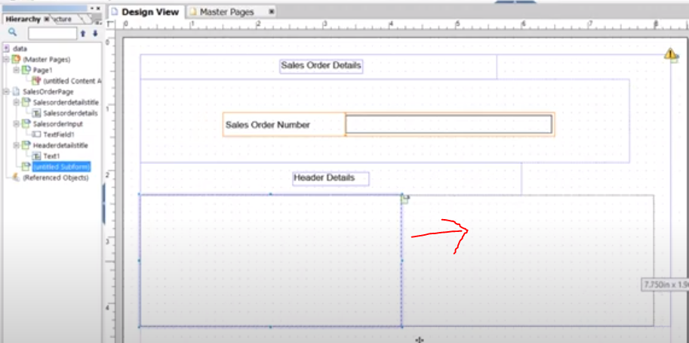

And just decrease some height and rename the sub form.

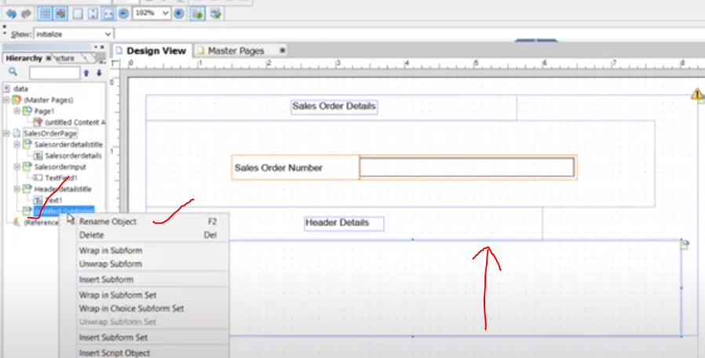

Rename the subform: HeaderValues.

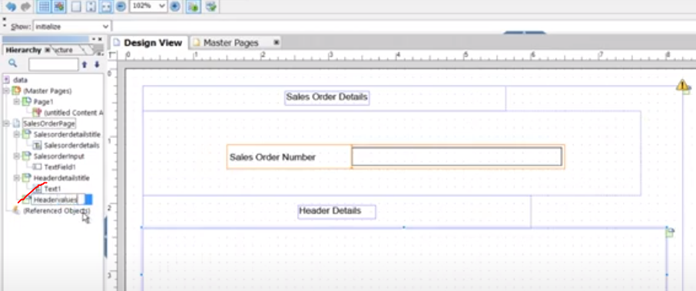

Inside the sub form we will create the 4-text fields:

**Creation Date:- Text Field.**

-- Now select the sub form🡪 go to the menu Insert🡪select the 0-Standard 🡪go for "Text Field"

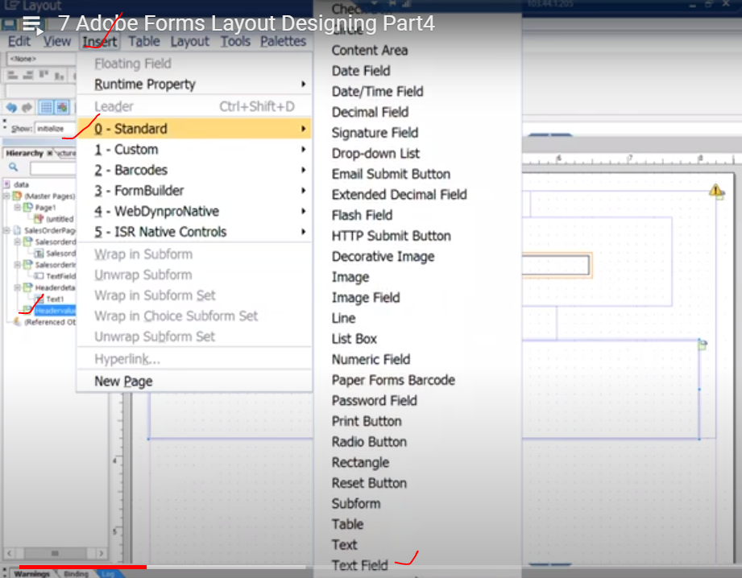

Text Field added in design view:

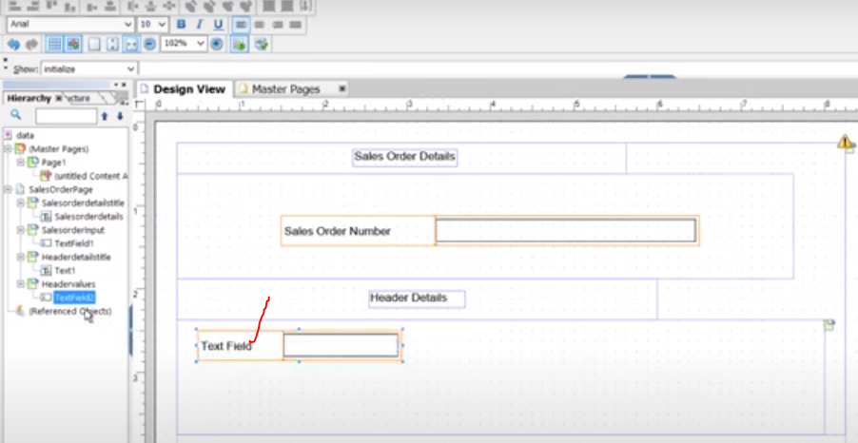

Rename the text field.--> select the text field right side 🡪rename it as "CreationDate"

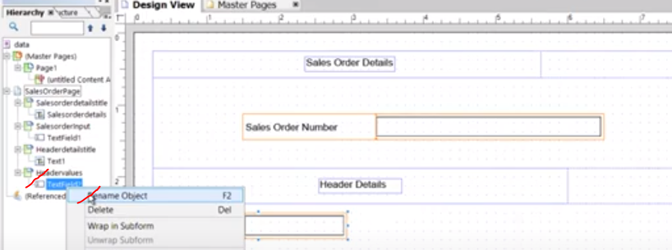

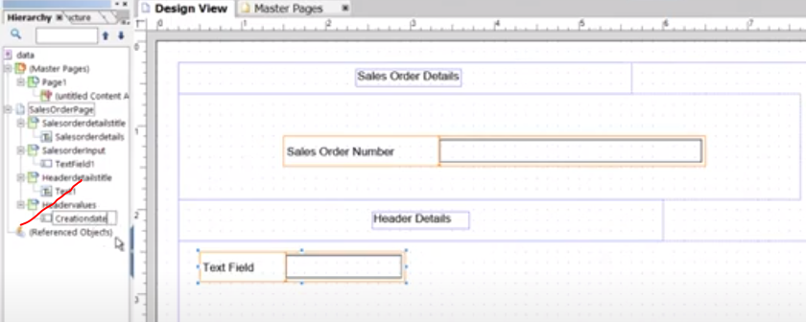

Put the proper description for Text Field: and description as "Creation Date"

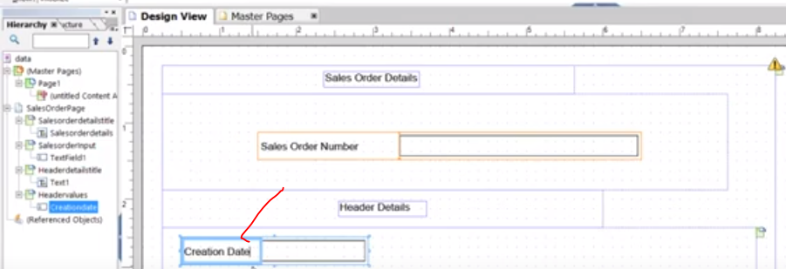

Now binding the value to the Creation Date input field.

Select the input date field: (Table data binding)

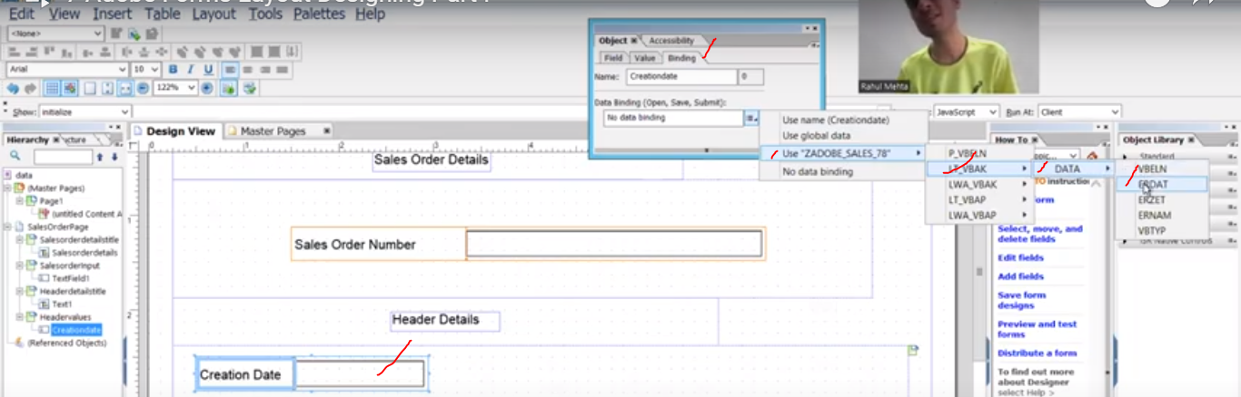

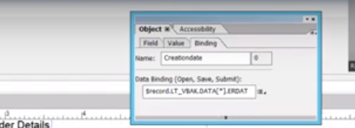

**Insert another text field: user name:**

Rename the user name text field as -user name:

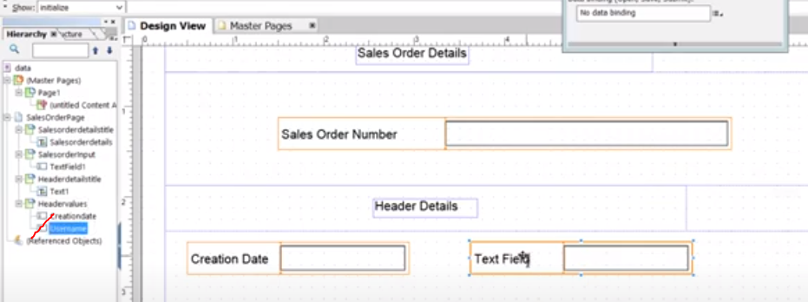

- change the proper description for text field in design level.

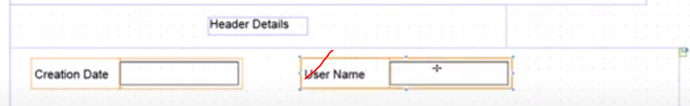

- Now bind the values to user name input field.

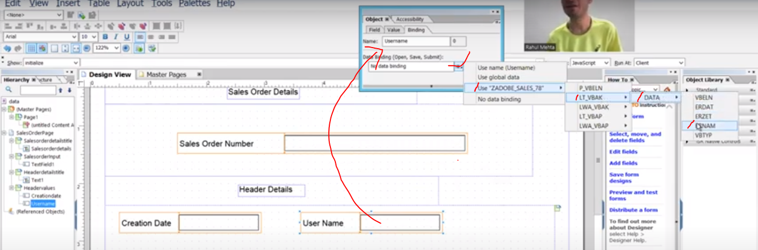



**Insert another text field-Time:**

Insert🡪0-Standard🡪text Field.

Rename the text field:

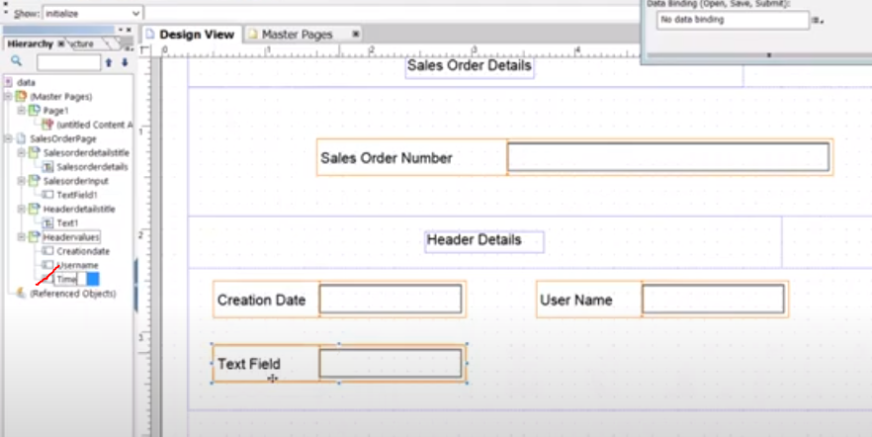

Change the Text field label name: Time(Double click )

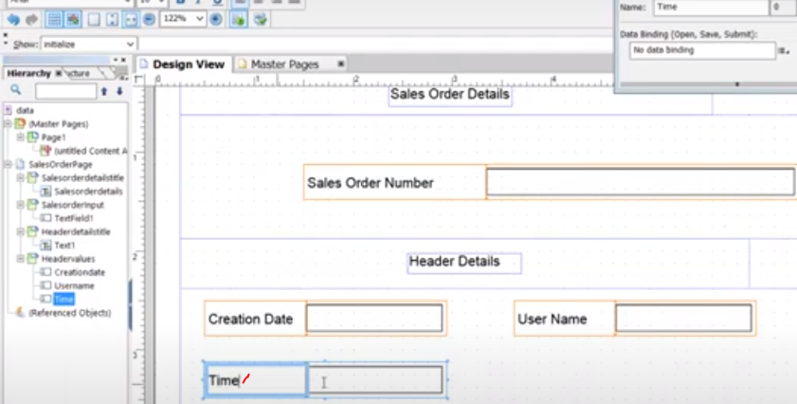

Bind the Time value to the Adobe form Interface.

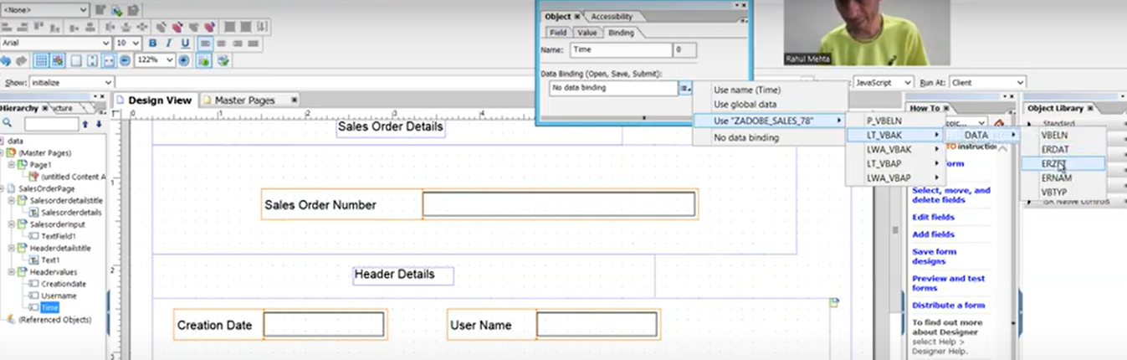

**Create another Text Field: For Document Category**